**NAME :** Arya M. Bhat

**ROLL N0:** CS2-09

**PRN :** 202401040044

EDS Theory Activity 1

IPL Dataset

**Problem Statements**

1. 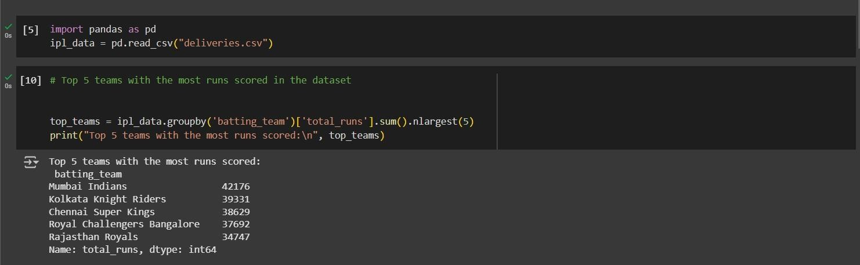Top 5 teams with the most runs scored in the dataset
2. Player with the most runs scored

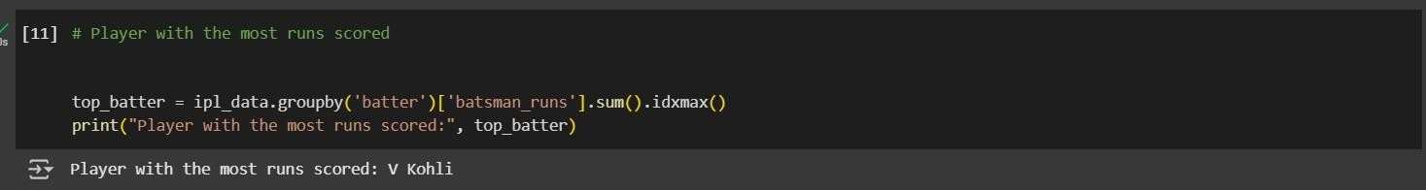

1. Bowler with the most wickets

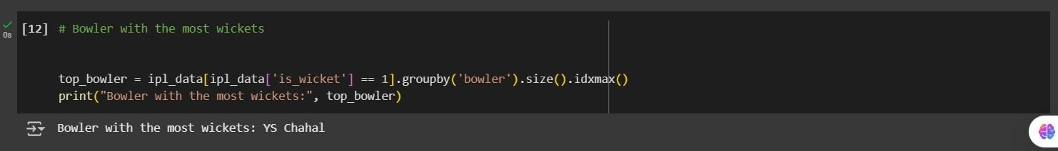

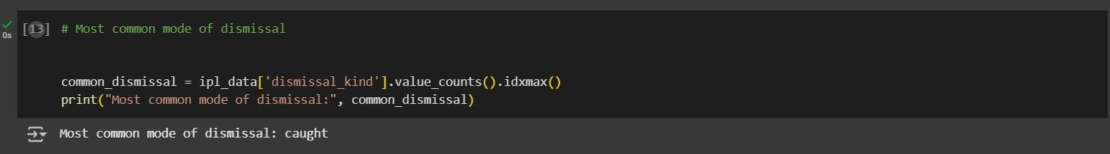

1. Average runs scored in each over across all matches

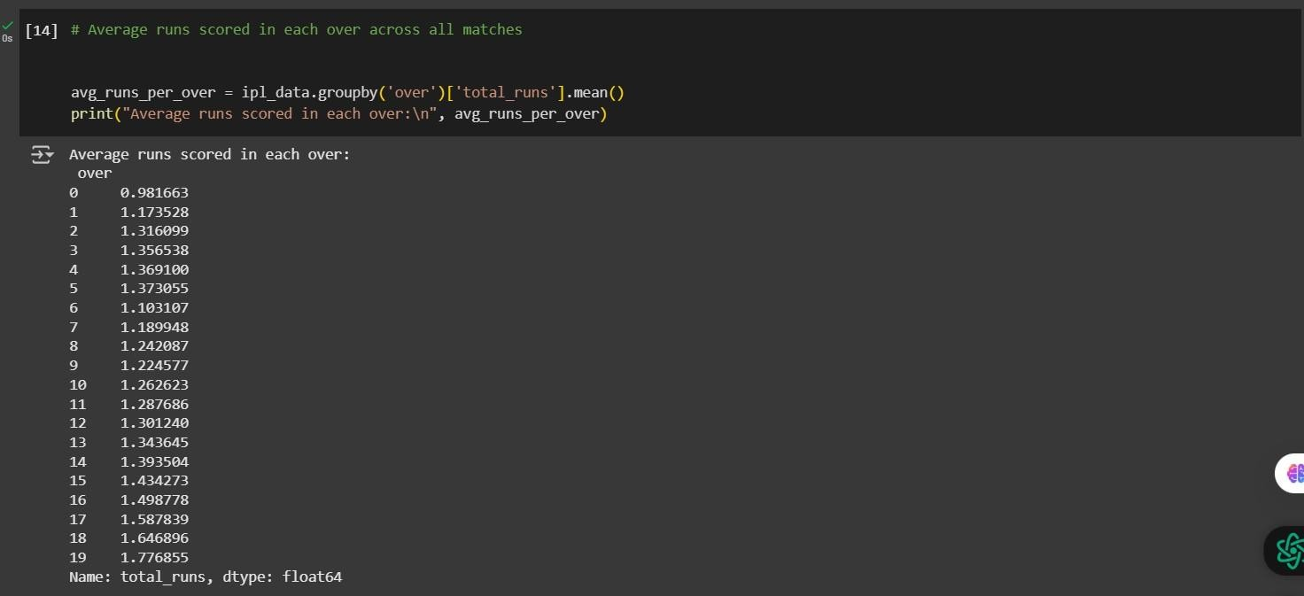

1. Total extras conceded by each team

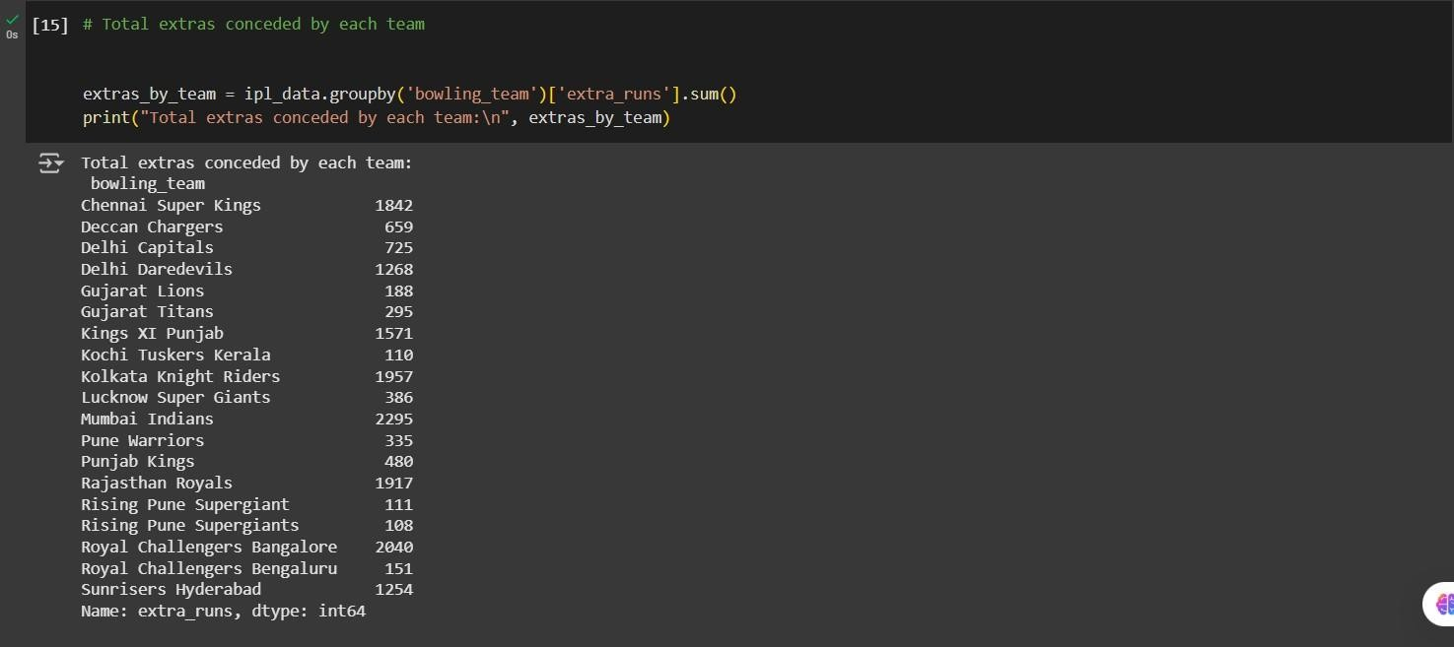

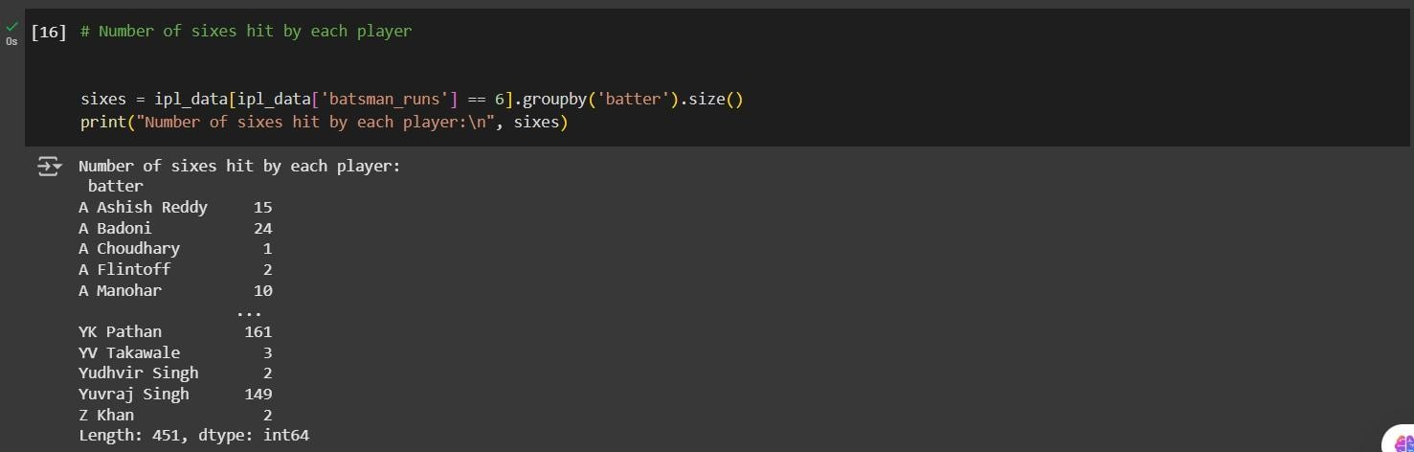

1. Matches with the highest total runs scored

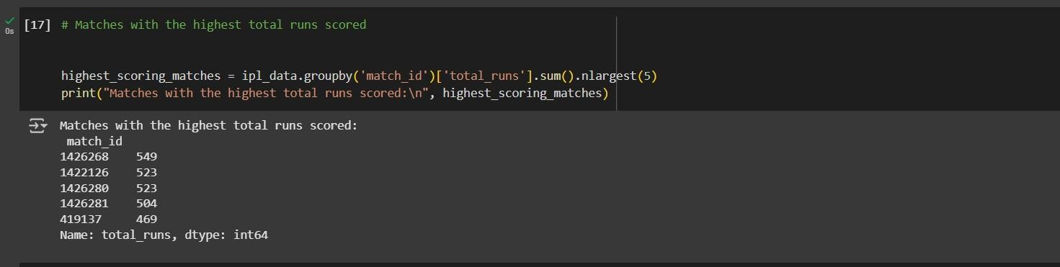

1. Distribution of wicket types across the dataset

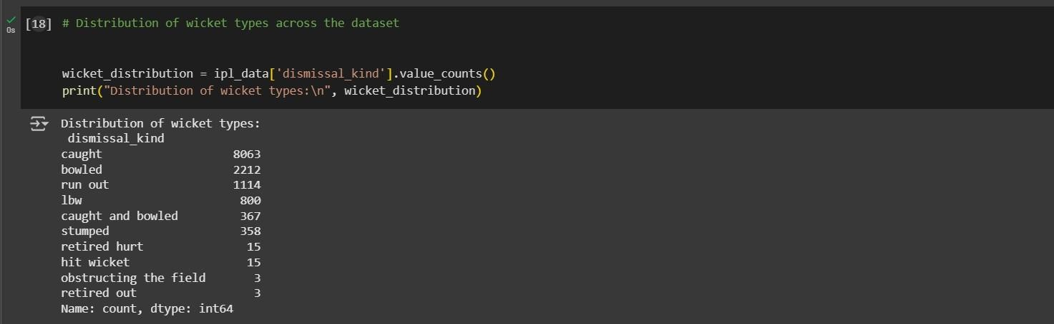

1. Top 5 bowlers conceding the most runs

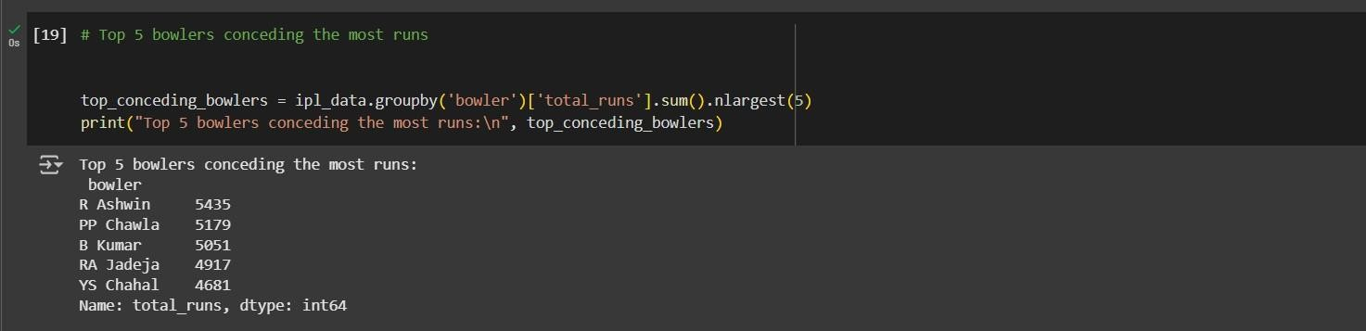

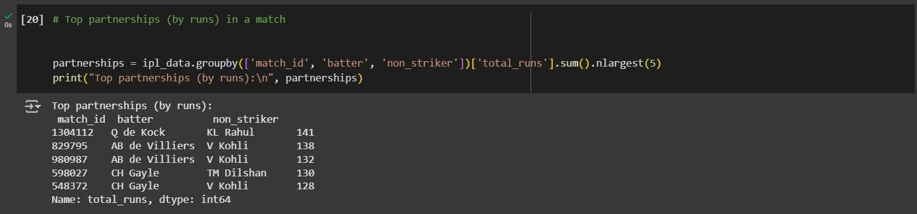

1. 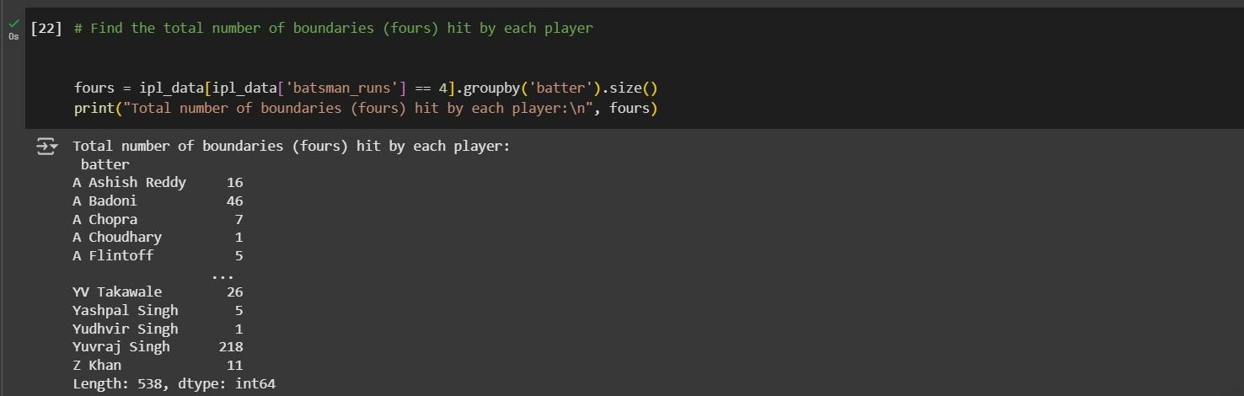Find the total number of boundaries (fours) hit by each player
2. Player dismissed most times by a specific bowler

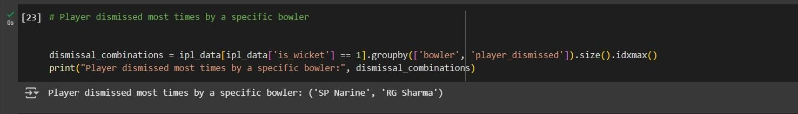

1. Most consistent batsmen (average runs per match)

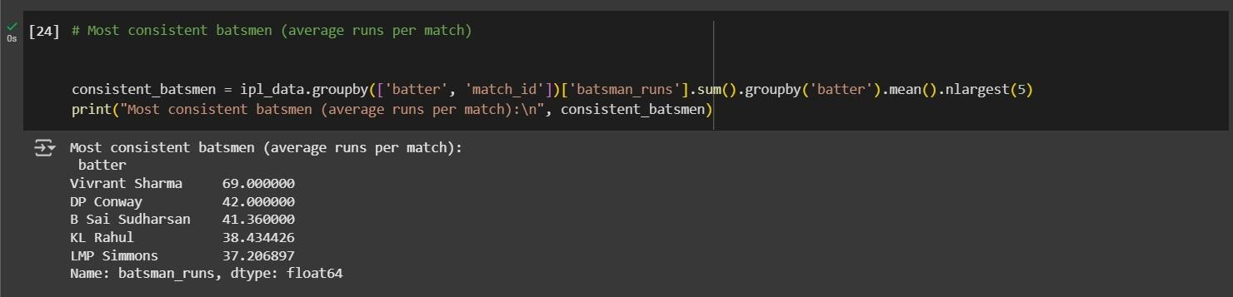

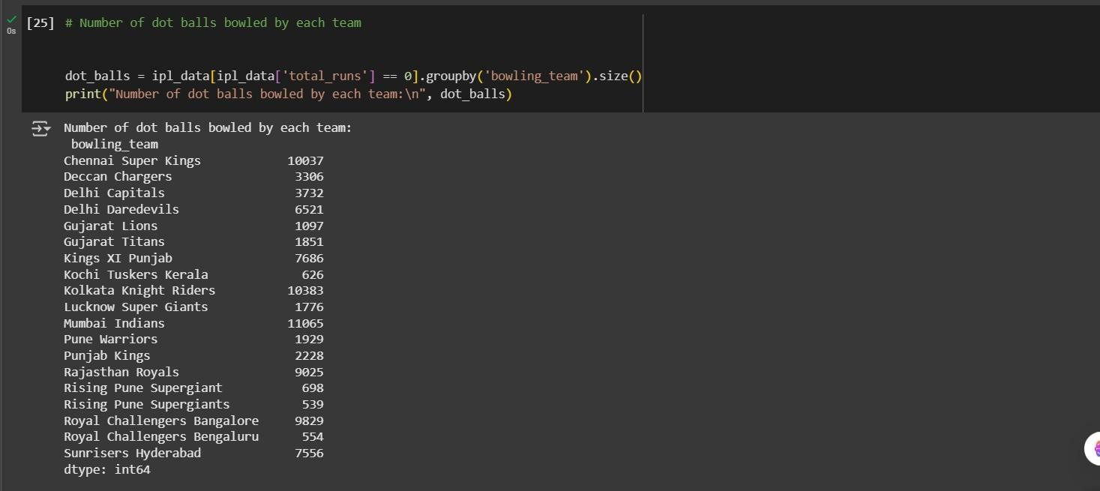

1. 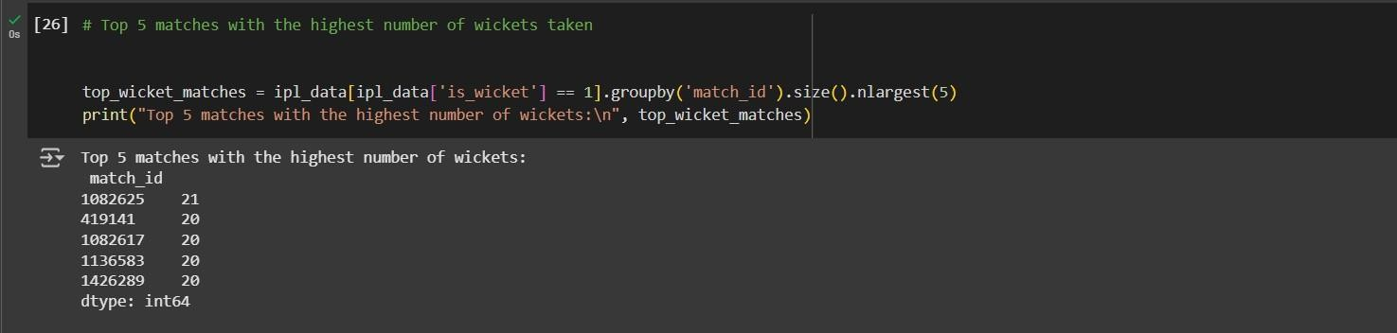Top 5 matches with the highest number of wickets taken
2. Total number of wides bowled by each team

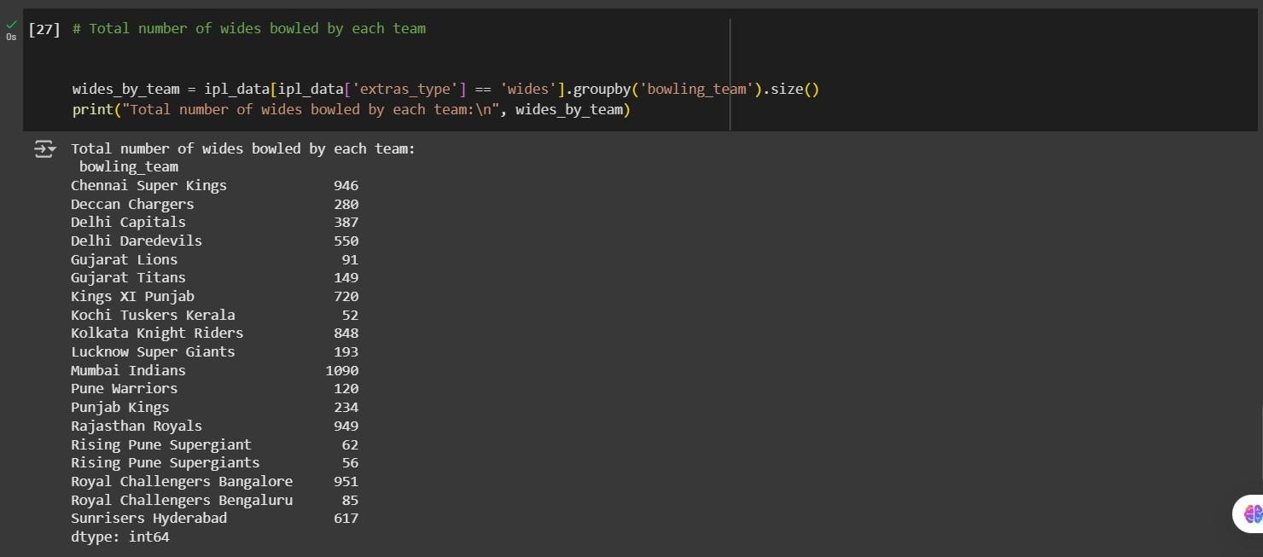

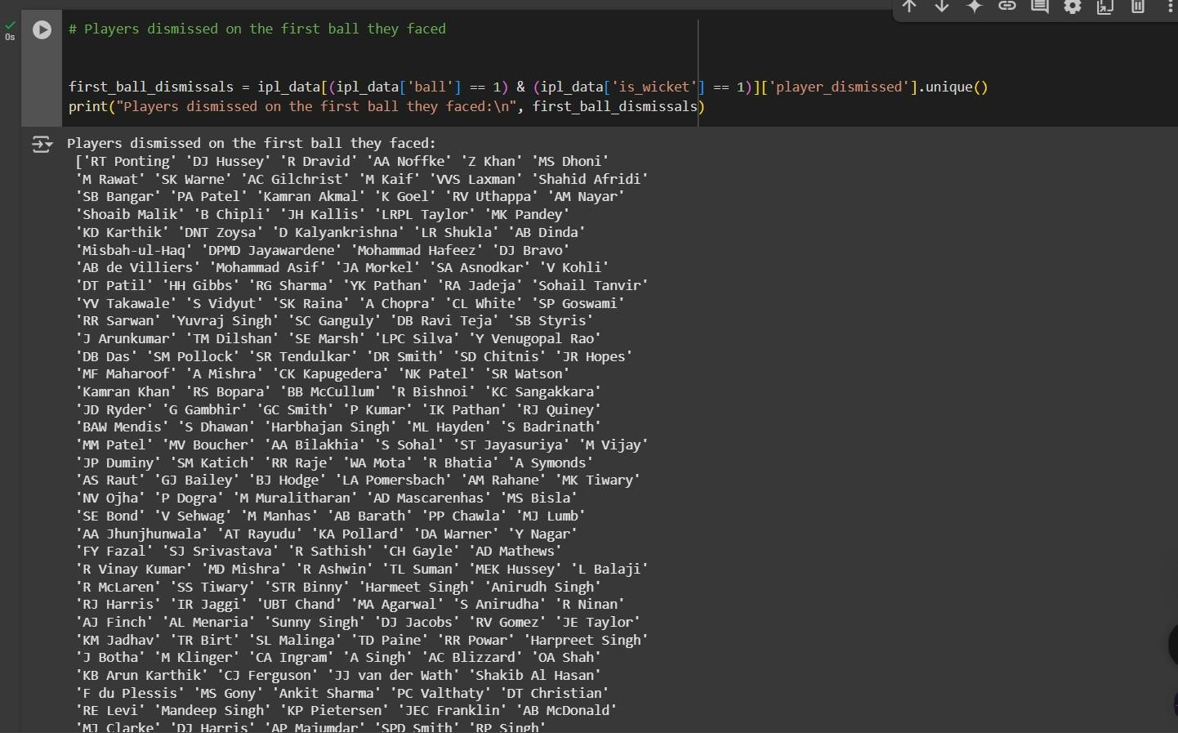

1. Top 5 fielders with the most catches

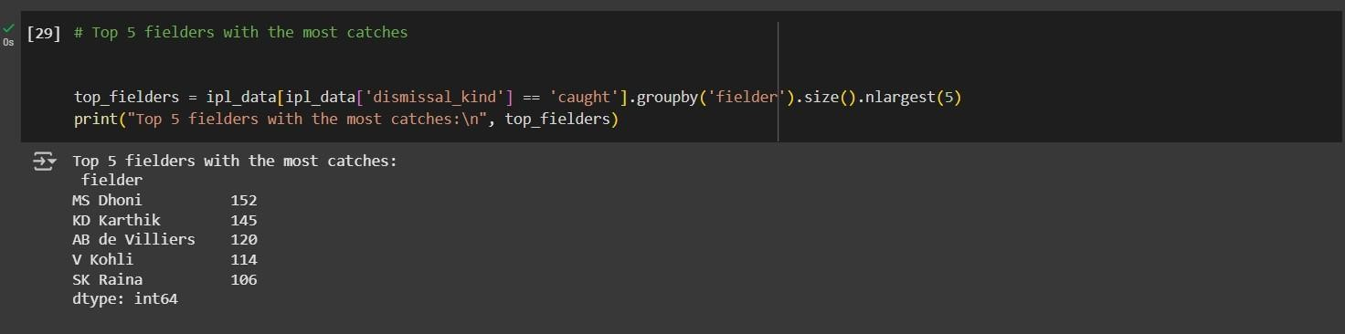

1. Number of maiden overs bowled by each bowler

